St. Cloud Math and Science Academy

Grades K - 8 School Supply List
(See other side for grades 4-8)

KINDERGARTEN

GRADE l

1 - Sturdy backpack to hold one or more books and other school- related items
1 - 8 count box BROADLINE CLASSIC COLOR Crayola markers
2 - Pocket Folders
2 - Wide line spiral notebooks
1 - 24 count box of SMALL crayons 1 - Package of pencils
4 - Glue Sticks
1 – Colored Pencils
1 - Child's size blunt scissor
(1 set of extra clothes)

1 - Sturdy backpack to hold one or more books and other school- related items
1 - 8 count box BROADLINE CLASSIC COLOR Crayola markers
2 - Pocket Folders
2 - Wide line spiral notebooks
1 - 24 count box of SMALL crayons 1 - Package of pencils
4 - Glue Sticks
1 – Colored Pencils
1 - Child's size blunt scissor
(1 set of extra clothes)

GRADE 2

GRADE 3

1 - Sturdy backpack to hold one or more books and other school- related items
1 - 8 count box BROADLINE CLASSIC COLOR Crayola markers
2 - Pocket Folders
2 - Wide line spiral notebooks
1 - 24 count box of SMALL crayons 1 - Package of pencils
4 - Glue Sticks
1 – Colored Pencils
1 - Child's size blunt scissor

1 - Sturdy backpack to hold one or more books and other school- related items
1 - 8 count box BROADLINE CLASSIC COLOR Crayola markers
2 - Pocket Folders
2 - Wide line spiral notebooks
1 - 24 count box of SMALL crayons 1 - Package of pencils
4 - Glue Sticks
1 – Colored Pencils
1 - Child's size blunt scissor

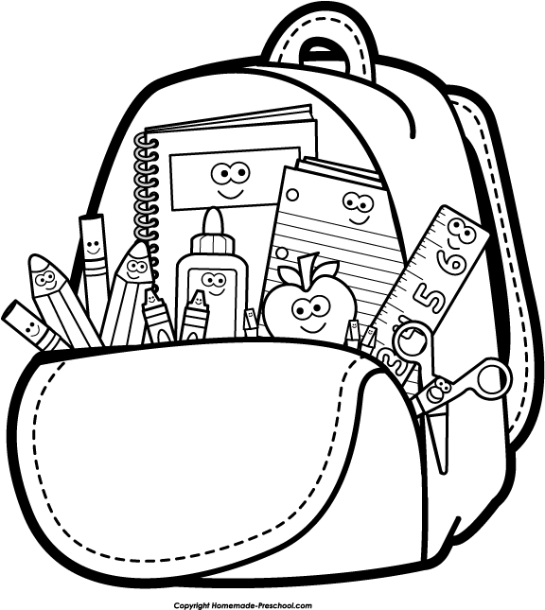
- ALL STUDENTS MUST HAVE RUBBER-SOLED TENNIS SHOES for gym class, no sandals.

* All students please have a backpack and water bottle.
St. Cloud Math and Science Academy Grades K - 8 School Supply List (See other side for Grades KG-3)

.
- I
GRADES 4-5

GRADES 6-8
1 - Sturdy backpack to hold one or more books and other school- related items
1 - 8 count box BROADLINE CLASSIC COLOR Crayola markers 4 - Pocket Folders
4 - Wide line spiral notebooks
1 - 24 count box of SMALL crayons 1 - Package of pencils
4 - Glue Sticks
1 - 12 count-colored pencils
1 - Child's size blunt scissor
1 – Large soft eraser (pink)
1 - Highlighter

1 - Sturdy backpack to hold one or more books and other school- related items
1 - 8 count box BROADLINE CLASSIC COLOR Crayola markers
2 - Pocket Folders
2 - Spiral notebooks
1 – 24 count box of SMALL crayons
1 – Package of pencils
1 – 12 count-colored pencils
1 – Highlighter
2 – Erasers
1 – Composition notebook
1 – Pencil Pouch
2 – Glue sticks
1 – Binder Trapper Keeper
1 – Pack loose leaf paper (7th & 8th grades)
1 – Scientific Calculator

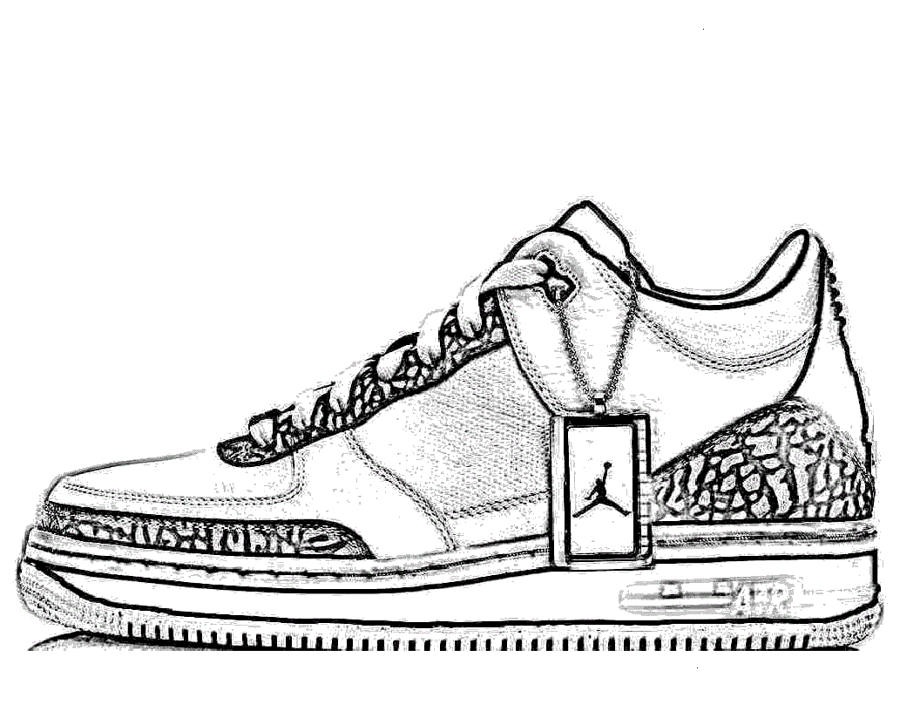
- ALL STUDENTS MUST HAVE RUBBER-SOLED TENNIS SHOES for gym class, no sandals.
Re-supply all items as needed throughout the school year please.

- All students please have a backpack and water bottle.

